ACE INSTITUTE OF MANAGEMENT


Pokhara University

Faculty of Management
Bachelor in Computer System and Information Technology (BCSIT)

Final Project Report
SECOND HAND BOOK MARKET

Submitted by:
Rojin Ghimire
Prashant karki
Shaswat Pokhrel
Subarna bahadur shahi

Submitted to:
Sanju Shrestha
ACE Institute of Management Date: June 2026

Abstract
Abstract
ReBook is a web-based second-hand book marketplace designed to help students buy and sell used academic books conveniently and affordably. The system addresses the problem of expensive textbooks and the underutilization of books after course completion by providing a dedicated platform for book exchange among students. The application allows users to register, log in, list books for sale, browse available books, search and filter books, and send purchase requests to sellers. It also includes a user dashboard for managing book listings and requests, as well as an admin panel for managing users and book records. The system is developed using HTML, CSS, JavaScript, Node.js, Express.js, and MySQL following a three-tier architecture. The proposed solution is technically, operationally, and economically feasible, utilizing open-source technologies and requiring minimal resources. The expected outcome is a user-friendly online marketplace that reduces educational costs, promotes book reuse, and provides students with an efficient platform for buying and selling second-hand academic books.

Acknowledgements
We would like to express our sincere gratitude to our project supervisor, Sanju Shrestha, for his continuous guidance, valuable suggestions, constructive feedback, and unwavering support throughout the development of this project. His expertise and encouragement greatly contributed to the successful completion of this work.
We would also like to thank the faculty members of ACE Institute of Management, Pokhara University, for providing us with the knowledge, resources, and academic environment necessary for carrying out this project.
Our heartfelt appreciation goes to our families, friends, and peers for their constant motivation, encouragement, and support during the project development process. Finally, we would like to acknowledge the developers and contributors of the open-source technologies and tools used in building ReBook – Second-Hand Book Marketplace, which played a significant role in the successful implementation of this system.
We are grateful to everyone who directly or indirectly contributed to the completion of this project.

Table of Contents
Abstract ........................................................................................................ i
Acknowledgements ...................................................................................... ii
Table of Contents ....................................................................................... iii
List of Figures ............................................................................................ iv
List of Tables .............................................................................................. v
List of Abbreviations ................................................................................. vi
Chapter 1: Introduction ........................................................................ 1
1.1 Background of the Study ...................................................................... 1
1.2 Statement of the Problem .................................................................... 2
1.3 Objectives of the Study ........................................................................ 3
1.4 Scope of the Study ............................................................................... 4
1.5 Limitations of the Study ...................................................................... 4
Chapter 2: Literature Review ............................................................... 5
2.1 Theoretical Background ....................................................................... 5
2.2 Review of Similar Systems .................................................................. 7
Chapter 3: System Analysis and Design .............................................. 9
3.1 Requirement Analysis .......................................................................... 9
3.2 Feasibility Study ................................................................................ 11
3.3 Data Modelling .................................................................................. 13
3.4 Process Modelling .............................................................................. 14
3.5 System Design .................................................................................... 15
Chapter 4: Implementation and Testing ............................................. 19
4.1 Implementation ................................................................................. 19
4.2 Testing .............................................................................................. 22
Chapter 5: Conclusion and Future Recommendations ...................... 25
5.1 Lessons Learnt .................................................................................. 25
5.2 Conclusion ........................................................................................ 25
5.3 Future Recommendations .................................................................. 26
References ............................................................................................... 27
Appendices ............................................................................................... 29
List of Figures
Figure 3.1: Use Case Diagram of ReBook System ..................................... 10
Figure 3.2: Activity Diagram of Book Purchase Process .......................... 14
Figure 3.3: System Architecture Diagram ............................................... 16
Figure 3.4: Entity Relationship (ER) Diagram ......................................... 17
Figure 4.1: Homepage Interface .............................................................. 20
Figure 4.2: User Dashboard Interface ..................................................... 21
Figure 4.3: Book Upload Interface .......................................................... 21
Figure 4.4: Admin Dashboard Interface ................................................. 22
List of Tables
Table 3.1: Functional Requirements ....................................................... 9
Table 3.2: Non-Functional Requirements .............................................. 10
Table 3.3: Feasibility Analysis Summary ............................................... 12
Table 3.4: Database Tables Description ................................................. 18
Table 4.1: Tools and Technologies Used ............................................... 19
Table 4.2: Unit Test Cases ..................................................................... 22
Table 4.3: System Test Cases ................................................................ 23
List of Abbreviations
BCSIT – Bachelor in Computer System and Information Technology
CRUD – Create, Read, Update, Delete
CSS – Cascading Style Sheets
ER – Entity Relationship
HTML – HyperText Markup Language
HTTP – HyperText Transfer Protocol
JS – JavaScript
MVC – Model View Controller
MySQL – My Structured Query Language
Node.js – JavaScript Runtime Environment
SQL – Structured Query Language
UI – User Interface
URL – Uniform Resource Locator
UX – User Experience
WAMP – Windows, Apache, MySQL, PHP

Chapter 1: Introduction

1.1 Background of the Study
In today’s academic environment, access to affordable educational resources plays a crucial role in supporting student success. Textbooks and reference materials are often expensive, and many students are unable to purchase new books every semester. As a result, a large number of books remain unused after course completion, while other students continue to face difficulty in obtaining the required study materials.
The ReBook – Second-Hand Book Marketplace is a web-based platform designed to address this gap by enabling students to buy and sell used academic books efficiently. The system promotes the reuse of educational resources and helps reduce the financial burden on students by providing an accessible digital marketplace for book exchange.
The platform is developed using standard web technologies including HTML, CSS, and JavaScript for the frontend, Node.js with Express.js for the backend, and MySQL as the database management system. This combination ensures scalability, maintainability, and compatibility across modern web browsers without requiring additional proprietary tools.

1.2 Statement of the Problem
Despite the availability of online marketplaces, there is a lack of dedicated platforms focused specifically on academic second-hand books. General e-commerce platforms are often cluttered, making it difficult for students to find relevant educational materials efficiently. Additionally, there is no structured system that connects buyers and sellers within the same academic community.
Students frequently face challenges such as high textbook costs, limited availability of used books, and inefficient communication between buyers and sellers. Many existing platforms also lack features such as academic categorization, semester-wise filtering, and simplified purchase request systems tailored for students.
Therefore, there is a need for a simple, efficient, and student-focused marketplace that allows users to list books, search by academic relevance, and complete transactions in a structured and user-friendly environment.

1.3 Objectives of the Study
The main objective of this project is to design and develop a web-based second-hand book marketplace that enables students to buy and sell used academic books efficiently. The specific objectives are:
- To allow users to register, log in, and manage their accounts securely.
- To enable users to list books for sale with details such as title, author, category, price, and condition.
- To provide a searchable and filterable marketplace for browsing available books.
- To implement a purchase request system for communication between buyers and sellers.
- To design a user dashboard for managing listed books and purchase requests.
- To develop an admin panel for managing users and book listings.
- To ensure secure data storage and authentication using a database system.
- To create a responsive and user-friendly interface for both desktop and mobile users.

1.4 Scope of the Study
The scope of the ReBook system includes the development of a web-based platform for buying and selling second-hand academic books among students.
- The system supports user registration, login, and profile management.
- Users can perform full CRUD operations on book listings.
- The system provides search, filtering, and category-based browsing of books.
- A purchase request mechanism is implemented to connect buyers and sellers.
- The application is accessible through modern web browsers without installation.
- The backend is developed using Node.js and Express.js with MySQL database integration.
The system is designed as a student-focused marketplace and does not include full-scale commercial e-commerce features such as payment gateway integration in this version.

1.5 Limitations of the Study
The following limitations have been identified in the current version of the system:
- The platform is limited to academic book exchange and does not support general product trading.
- Real-time chat functionality between users is not implemented.
- Online payment gateway integration is not included in this version.
- The recommendation system is basic and does not use advanced machine learning techniques.
- The system has been tested in a local development environment and not deployed at a production scale.
- Mobile native application support is not available; the system is only web-based.

Chapter 2: Literature Review

2.1 Theoretical Background

2.1.1 E-Commerce and Online Marketplaces
E-commerce refers to the buying and selling of goods and services through electronic systems, primarily the internet. Online marketplaces provide a digital platform where multiple users can interact as buyers and sellers. According to Laudon and Traver (2020), e-commerce platforms enhance accessibility, reduce transaction costs, and improve market efficiency by eliminating geographical barriers.
The ReBook system is based on this concept of an online marketplace, specifically tailored for second-hand academic books. It facilitates direct interaction between students, enabling them to exchange used textbooks efficiently within a shared academic environment.

2.1.2 Second-Hand Goods and Resource Reuse Theory
The concept of second-hand goods is closely related to sustainable consumption and resource reuse. Studies suggest that reusing products extends their lifecycle, reduces waste, and promotes economic efficiency. In educational contexts, textbook reuse significantly reduces financial burden on students while encouraging sustainable academic practices.
ReBook applies this principle by providing a structured platform where used academic books can be resold and reused among students, thereby promoting both affordability and sustainability.

2.1.3 User-Centered Design in Web Applications
User-centered design (UCD) focuses on developing systems that prioritize user needs, usability, and accessibility. According to Nielsen (1994), effective systems should be simple, intuitive, and efficient to use, minimizing cognitive load on users.
The ReBook system adopts UCD principles by providing a clean interface, simple navigation, category-based browsing, and easy book listing features to ensure a smooth user experience for students with varying technical skills.

2.1.4 Web Application Architecture
Modern web applications commonly follow a three-tier architecture consisting of presentation, application, and data layers (Pressman & Maxim, 2019). This separation improves system maintainability, scalability, and security.
ReBook follows this architecture using HTML, CSS, and JavaScript for the frontend, Node.js with Express.js for backend logic, and MySQL as the database layer. This structure ensures efficient data flow and modular system development.

2.2 Review of Similar Systems

2.2.1 Amazon Marketplace
Amazon (https://www.amazon.com/) is one of the largest global e-commerce platforms that supports third-party selling. It provides advanced search, recommendation systems, and secure transaction processing. However, it is designed for large-scale commercial use and lacks specialization for academic book exchange between students.

2.2.2 OLX
OLX (https://www.olx.com/) is a popular online classifieds platform that allows users to buy and sell used items locally. While it supports second-hand trading, it is a general-purpose platform and does not provide academic categorization such as semester-wise or subject-wise filtering, which is essential for student-focused marketplaces.

2.2.3 Daraz Nepal
Daraz (https://www.daraz.com.np/) is a leading e-commerce platform in Nepal offering a wide range of products. It provides seller dashboards, product listings, and order management features. However, its complexity and commercial focus make it less suitable for a simplified student-oriented book exchange system.

2.2.4 Facebook Marketplace
Facebook Marketplace enables users to buy and sell products within social networks. Although it provides high accessibility, it lacks structured academic categorization, verification systems, and dedicated educational resource filtering, making it less efficient for targeted book exchange.

2.2.5 Gap Analysis
The review of existing systems highlights several gaps that ReBook aims to address. These include the lack of academic-focused categorization, absence of structured semester and subject-based filtering, limited student-centric design, and inefficient book discovery for educational needs.
ReBook fills these gaps by providing a dedicated platform specifically designed for students, enabling efficient listing, searching, and exchanging of second-hand academic books in a structured and user-friendly environment.

Chapter 3: System Analysis and Design

3.1 Requirement Analysis

3.1.1 Functional Requirements
The table below lists the functional requirements of the ReBook – Second-Hand Book Marketplace system:
Req. ID | Requirement | Description
FR-01 | User Registration | Users can create an account with username, email, phone, and password.
FR-02 | User Login/Logout | Users can securely log in and log out of their accounts using session management.
FR-03 | User Profile Management | Users can view and update their profile information.
FR-04 | Add Book | Users (sellers) can list second-hand books with details such as title, author, category, price, and condition.
FR-05 | View Books | Users can view all available books on the marketplace dashboard.
FR-06 | Update Book | Sellers can edit details of their listed books.
FR-07 | Delete Book | Sellers can remove their book listings from the system.
FR-08 | Book Search | Users can search books by title, author, or category.
FR-09 | Book Filtering | Users can filter books based on price, category, and condition.
FR-10 | Purchase Request | Buyers can send purchase requests for selected books.
FR-11 | Request Management | Sellers can accept or reject purchase requests.
FR-12 | Status Tracking | Users can track request status (Pending, Accepted, Rejected).
FR-13 | Admin Management | Admin can manage users and book listings.
Table 3.1: Functional Requirements

3.1.2 Non-Functional Requirements
Category | Requirement | Target
Performance | Page load time | Under 3 seconds on standard broadband
Security | Authentication | Password hashing (bcrypt) and session management
Usability | Interface design | Simple, intuitive, and user-friendly UI
Reliability | System availability | 99% uptime during testing phase
Compatibility | Browser support | Chrome, Firefox, Edge, Safari (latest versions)
Maintainability | Code structure | MVC-like separation of frontend and backend logic
Scalability | Database design | Normalised schema supporting future growth
Table 3.2: Non-Functional Requirements

3.1.3 Use Case Diagram
The use case diagram below illustrates the interactions between system actors — User (Buyer/Seller) and Admin — and the core functionalities of the ReBook system.
Figure 3.1: Use Case Diagram of ReBook System

3.2 Feasibility Study

3.2.1 Technical Feasibility
The ReBook system is developed using widely used and open-source technologies such as HTML, CSS, JavaScript, Node.js, Express.js, and MySQL. These technologies are well-documented, freely available, and supported across all modern systems. The system does not require specialized hardware and can be developed and deployed using a standard development environment, making it technically feasible.

3.2.2 Operational Feasibility
The system is designed with simplicity and usability in mind, targeting students as primary users. The interface follows common e-commerce patterns, making it easy to navigate without formal training. The system is fully browser-based, requiring no installation on the user side.

3.2.3 Economic Feasibility
All technologies used in the development of ReBook are open-source and free of cost. No paid licenses or proprietary tools are required. Hosting can be done on low-cost or free-tier servers, making the system economically viable for academic purposes.

3.2.4 Schedule Feasibility
The project was developed within a structured timeline as per the academic schedule. Each phase, including requirement analysis, design, implementation, and testing, was completed step by step within the allocated timeframe.
Feasibility Type | Assessment | Verdict
Technical | Modern open-source web stack | Feasible
Operational | Simple UI, browser-based system | Feasible
Economic | No licensing cost required | Feasible
Schedule | Completed within academic timeline | Feasible
Table 3.3: Feasibility Summary

3.3 Data Modelling
The Entity Relationship (ER) diagram of the ReBook system represents the logical structure of the database. The system consists of four main tables: USERS, BOOKS, PURCHASE_REQUESTS, and WISHLIST.
Each user can list multiple books for sale, and each book belongs to a single seller. Buyers can send purchase requests for books, and each request is tracked with a status such as Pending, Accepted, or Rejected.

Key Database Tables
- USERS: user_id (PK), fullname, email, password (hashed), phone, role, created_at
- BOOKS: book_id (PK), seller_id (FK), title, author, category, price, condition, description, image, status, created_at
- PURCHASE_REQUESTS: request_id (PK), buyer_id (FK), book_id (FK), status, request_date
- WISHLIST: wishlist_id (PK), user_id (FK), book_id (FK)
Figure 3.2: Entity Relationship (ER) 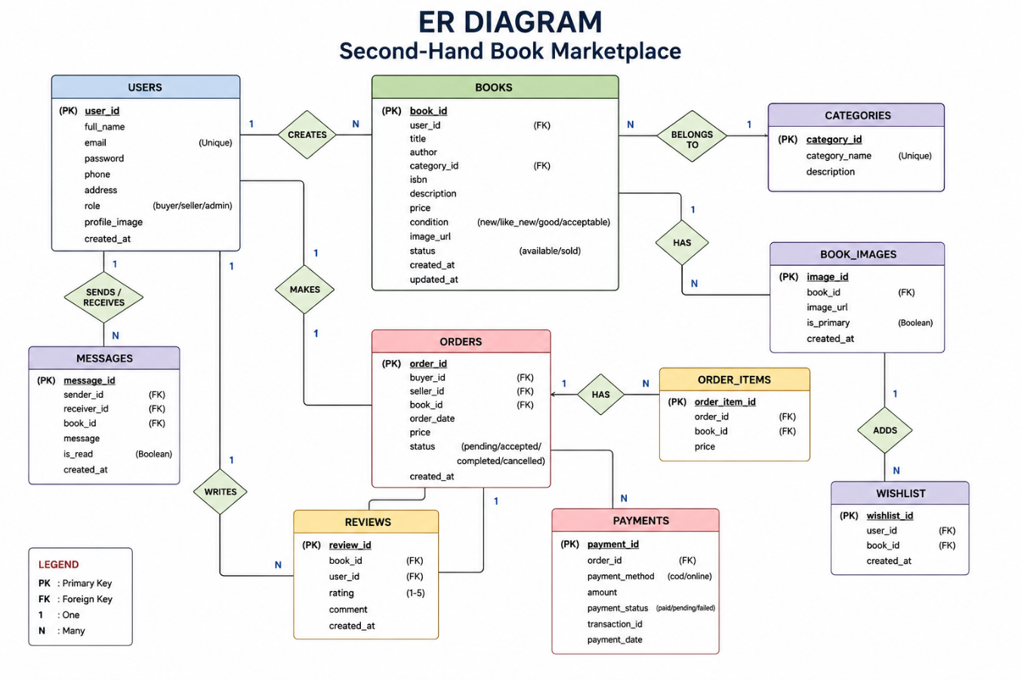Diagram of ReBook System

3.4 Process Modelling
The system flow begins when a user registers or logs in to the system. After authentication, users can browse available books, search or filter results, and view book details. Buyers can send purchase requests, which are then processed by sellers who can accept or reject them. The system updates request status accordingly and maintains transaction records.
Figure 3.3: Activity Diagram of Book Purchase Process
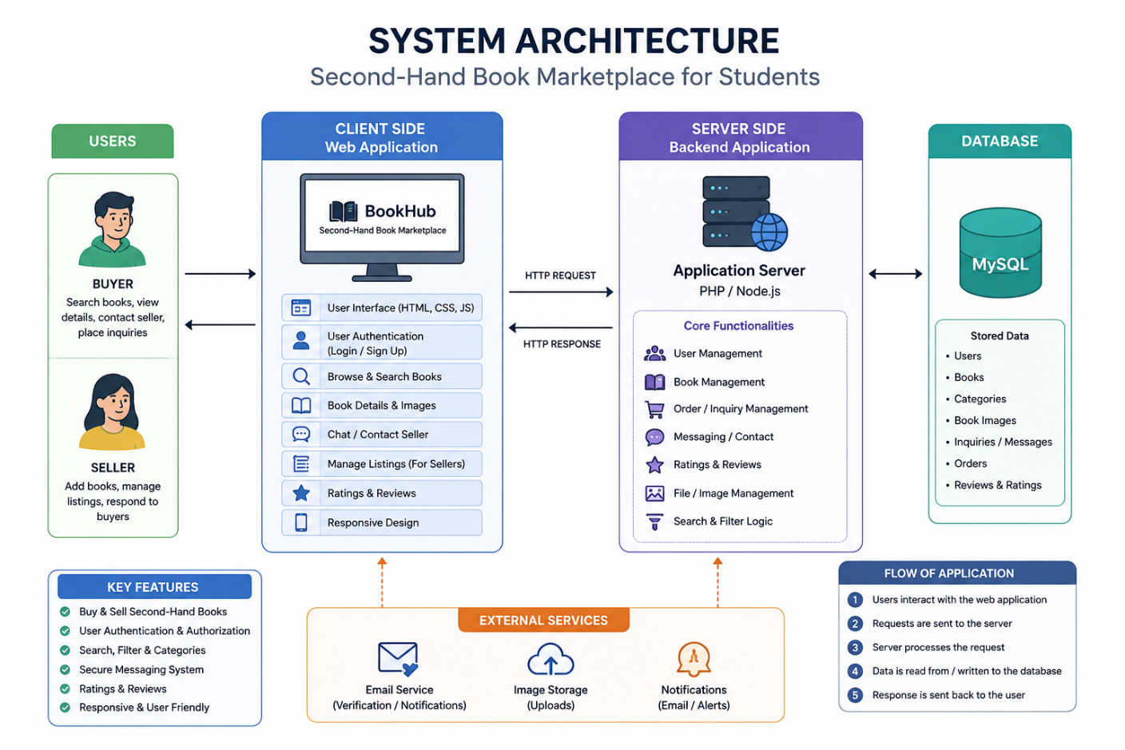

3.5 System Design

3.5.1 System Architecture
ReBook follows a three-tier client-server architecture consisting of:
- Presentation Layer – HTML, CSS, JavaScript (User Interface)
- Application Layer – Node.js with Express.js (Business Logic)
- Data Layer – MySQL Database (Data Storage)
Figure 3.4: System Architecture Diagram


3.5.2 Architectural Layer Description
Presentation Layer (Frontend):
Handles user interaction including homepage, book listings, search filters, login/register forms, and dashboards.
Application Layer (Backend):
Handles authentication, book management, purchase requests, and business logic using Express.js APIs.
Data Layer (Database):
Stores all persistent data such as users, books, and transactions in a structured MySQL database with normalized relationships.

3.5.3 Interface Design
The system includes the following interfaces:
- Login/Register Page: Secure authentication forms for user access.
- Homepage: Displays featured books, categories, and search functionality.
- Book Listing Page: Shows all available books with filters and search options.
- Book Detail Page: Displays complete information about a selected book.
- User Dashboard: Allows users to manage books, requests, and profile.
- Admin Panel: Provides administrative control over users and listings.

Chapter 4: Implementation and Testing

4.1 Implementation

4.1.1 Tools and Technologies Used
The ReBook system is developed using modern web technologies to ensure scalability, maintainability, and ease of use.
Category | Tool / Technology | Purpose
Frontend | HTML5 | Structure and layout of web pages
Frontend | CSS3 | Styling, responsiveness, and UI design
Frontend | JavaScript (ES6) | Dynamic interactions, form validation, and UI behavior
Backend | Node.js | Server-side runtime environment
Backend | Express.js | API routing and backend logic
Database | MySQL 8.x | Relational database for storing application data
Server | Apache / Node Server | Local development and execution
Design Tool | Figma | UI/UX wireframing and prototyping
Diagram Tool | draw.io | ER diagrams, use case diagrams, and architecture design
Version Control | Git / GitHub | Source code management and collaboration
Code Editor | Visual Studio Code | Primary development environment
Table 4.1: Tools and Technologies Used

4.1.2 Module Implementation Details

User Authentication Module
The authentication module handles user registration, login, and session management. During registration, user passwords are securely stored using hashing techniques (bcrypt). Login validation compares user credentials with stored records in the database. Session management ensures that authenticated users remain logged in while accessing protected pages, improving both security and usability.

Book Management Module (CRUD)
This module allows sellers to perform Create, Read, Update, and Delete operations on book listings. When a user adds a book, the details are stored in the BOOKS table with a reference to the seller’s user ID. Users can edit or remove their listings at any time. All operations are handled through Express.js API endpoints connected to MySQL using prepared statements to ensure security.

Book Search and Filter Module
The system provides a search feature that allows users to find books by title, author, or category. Additionally, filtering options enable users to refine results based on price range, condition, and academic category. This improves usability and helps buyers quickly find relevant books.

Purchase Request Module
When a buyer is interested in a book, they can send a purchase request. This request is stored in the PURCHASE_REQUESTS table with a default status of "Pending." Sellers can review incoming requests and either accept or reject them. The status is updated accordingly, allowing both parties to track the transaction.

User Dashboard Module
The user dashboard provides a centralized interface where users can manage their activities. Sellers can view, edit, and delete their book listings, while buyers can track their purchase requests. The dashboard also displays account information and recent activity.

Admin Module
The admin module provides control over the entire platform. Admins can manage users, monitor book listings, and remove inappropriate content. This ensures the system remains clean, secure, and reliable.

4.2 Testing

4.2.1 Unit Testing
Unit testing was conducted to verify the functionality of individual modules in isolation.
Test ID | Module | Test Case | Expected Result
UT-01 | Authentication | Register with valid data | User successfully created
UT-02 | Authentication | Login with correct credentials | User logged in successfully
UT-03 | Authentication | Login with incorrect password | Error message displayed
UT-04 | Book Module | Add new book with valid data | Book saved to database
UT-05 | Book Module | Add book with missing fields | Validation error shown
UT-06 | Search Module | Search by book title | Relevant results displayed
UT-07 | Purchase Module | Send purchase request | Request stored as pending
UT-08 | Dashboard | Load user dashboard | User data displayed correctly
UT-09 | Admin Module | View all users | User list displayed
UT-10 | Admin Module | Delete book listing | Book removed from system
Table 4.2: Unit Test Cases

4.2.2 System Testing
System testing ensures that all modules work together as a complete integrated system.
Test ID | Test Scenario | Steps | Expected Result
ST-01 | User workflow | Register → Login → Add Book → Logout | Successful workflow execution
ST-02 | Dashboard view | Login → View dashboard | All user data displayed correctly
ST-03 | Search feature | Search for a book | Matching books displayed
ST-04 | Filter feature | Apply category filter | Filtered results shown
ST-05 | Purchase request | Send request for book | Request stored and visible to seller
ST-06 | Admin access | Login as admin | Admin dashboard displayed
ST-07 | Unauthorized access | Open dashboard without login | Redirect to login page
ST-08 | Delete operation | Delete book listing | Book removed from database
Table 4.3: System Test Cases

4.2.3 Testing Results Summary
All unit test cases were executed successfully without critical errors. System integration testing confirmed that all modules function correctly together. Minor UI alignment and responsiveness issues identified during testing were resolved during the final optimization phase. The system demonstrated stable performance, correct database operations, and secure authentication flow.

Chapter 5: Conclusion and Future Recommendations

5.1 Lessons Learnt
- Requirement Analysis is Essential: Proper understanding of user needs helped in designing a focused and student-centric book marketplace, reducing major changes during development.
- Database Design is Critical: A well-structured and normalized database made it easier to manage relationships between users, books, and purchase requests efficiently.
- Frontend and Backend Integration: Handling API requests between frontend JavaScript and Node.js/Express backend required careful attention to data formatting and error handling.
- Iterative Development Improves Quality: Developing and testing each module separately helped identify and fix issues early in the development process.
- User-Centered Design Matters: Keeping the interface simple and intuitive ensured that users could easily navigate and use the system without training.
- Documentation Enhances Development: Maintaining proper documentation alongside coding improved clarity and reduced confusion during integration.

5.2 Conclusion
The ReBook – Second-Hand Book Marketplace has been successfully designed, developed, and tested as a web-based platform for buying and selling used academic books. The system fulfills its main objectives by allowing users to register, list books, browse available listings, and send purchase requests efficiently.
The system is developed using modern web technologies including HTML, CSS, JavaScript, Node.js, Express.js, and MySQL following a three-tier architecture. This ensures scalability, maintainability, and ease of deployment on standard web servers.
ReBook provides a dedicated solution for students to exchange academic books within a single platform, reducing educational costs and promoting resource reuse. The system is lightweight, browser-based, and does not require any installation, making it easily accessible to users.
All functional and non-functional requirements were successfully implemented and tested, confirming that the system is stable, reliable, and suitable for real-world academic use.

5.3 Future Recommendations
- Online Payment Integration: Future versions can include secure payment gateways such as eSewa, Khalti, or Stripe for direct online transactions.
- Chat System: Implement real-time messaging between buyers and sellers to improve communication efficiency.
- Mobile Application: Develop Android and iOS applications to improve accessibility and enable push notifications.
- AI-Based Recommendations: Introduce intelligent book suggestions based on user behavior and browsing history.
- Advanced Search Filters: Add filters such as semester, faculty, popularity, and location-based search.
- Cloud Deployment: Deploy the system on cloud platforms like AWS or DigitalOcean for scalability and real-world usage.
- Rating and Review System: Allow users to rate sellers and books to increase trust and transparency within the platform.

References
- MDN Web Docs. (2024). HTML, CSS, and JavaScript Documentation. https://developer.mozilla.org/
- MySQL. (2024). MySQL 8.0 Reference Manual. Oracle Corporation. https://dev.mysql.com/doc/
- Node.js Documentation. (2024). https://nodejs.org/
- Express.js Guide. (2024). https://expressjs.com/
- Pressman, R. S., & Maxim, B. R. (2019). Software Engineering: A Practitioner’s Approach. McGraw-Hill Education.
- Nielsen, J. (1994). Usability Engineering. Morgan Kaufmann.
- Laudon, K. C., & Traver, C. G. (2020). E-commerce: Business, Technology, Society. Pearson.

Appendices

Appendix A: Gantt Chart (Project Timeline)
The Gantt chart represents the complete timeline and scheduling of the ReBook project. It illustrates the distribution of work across different phases including requirement analysis, system design, implementation, testing, and documentation.
Figure A.1: Gantt Chart – ReBook Project Timeline and Schedule
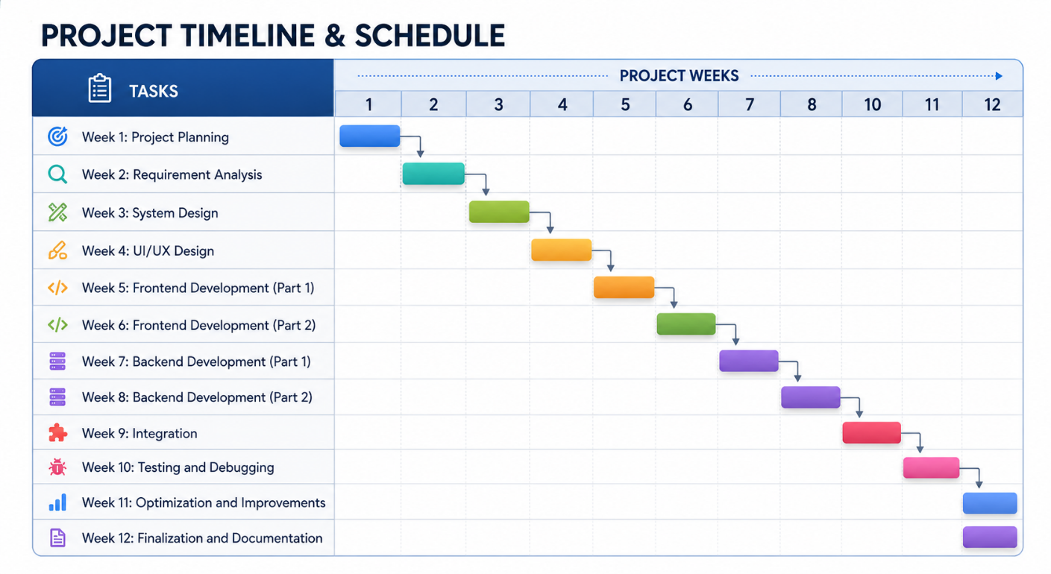

The project was carried out in a structured manner over the assigned academic period. Each phase was allocated specific time slots to ensure systematic development and timely completion. Requirement analysis and system design were completed in the initial phase, followed by backend and frontend development. Testing and debugging were conducted in the later stages to ensure system reliability and performance.

